**AI ASSISTED CODING**

**LAB ASSIGNMENT – 12.4**

**NAVYA MASADI**

**2403A53020**

**24BTCAICYB01-2-1**

**#TASK-1**

**Write a Python implementation of Bubble Sort.**

**PROMPT:**

C:\Users\WIN10\Pictures\Screenshots\Screenshot (449).png

**OUTPUT:**

**#TASK-2**

**Provide Bubble Sort code to AI and ask it to suggest a more efficient algorithm for partially sorted arrays.**

**PROMPT:**

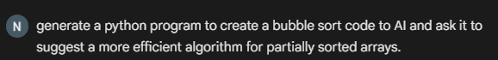

**OUTPUT:**



**#TASK-3**

Implement both **Linear Search** and **Binary Search**

**PROMPT:**

C:\Users\WIN10\Pictures\Screenshots\Screenshot (451).png

**OUTPUT:**



**#TASK-4**

**Implement Quick Sort and Merge Sort using recursion**

**PROMPT:**

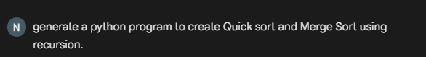

**OUTPUT:**



**#TASK-5**

**Give AI a naive algorithm (e.g., O(n²) duplicate search).**

**PROMPT:**

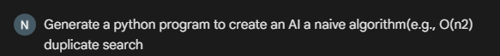

**OUTPUT:**



**­­­­­**